**Practice Test 1**

**Calculator Free Section**

**Name: _______________________ Score: _____ / 18**

**No calculators or notes are to be used.**

**Mathematics Specialist Formula Sheet is permitted**

**Time limit = 20 minutes**

**1. (4 marks)**

Given that *z* is a complex number solve  , giving the solution(s) exactly in the form *a* + *bi*.

2. (3 marks)

Rewrite $\left\{z:\left|z-\left(2+4i\right)\right|=\left|z-1\right|\right\}$ as a cartesian equation.

3. (3,3 = 6 marks)

**a)** Given $z=a-3i$ and $z+c\overline{z}=12+6i$, determine $a$ and $c$.

**b)** Given $w=bcis\frac{5π}{6}$ and $\left|{\left(\overline{w}\right)}^{3}\right|=0.001$, determine $b$

and give the principal argument of $w^{3}$.

**4. (5 marks)**

Use De Moivre's Theorem to find all the roots of z4 = -8 + 8√3i. Give your answers exactly in polar form, with r >0 and .

**End of Section One**

**Practice Test 1**

**Calculator Assumed Section**

**Name: _______________________ Score: _____ / 29**

**Calculators allowed and one double-sided page of A4 notes.**

**Mathematics Specialist Formula Sheet is permitted**

**Time limit = 30 minutes**

**5. (2,2,2,2 marks)**

Suppose that z is a complex number with modulus r and argument θ.

Express in terms of r and θ the modulus and argument of each of the

four complex numbers z1, z2, z3, and z4 where

( i ) z1 = z2

( ii ) z2 = 2z

( iii ) z3 = z-1

( iv ) z4 = -**i**z

**6. (2,2,2 marks)**

The complex numbers of *z* and *w* are such that:

*z* = 3cis(  ) and *w* = cis(  )

Determine the following.

**a)** *z* + *w* (in a + b***i*** form)

**b)** *wz* (in cis form)

**c) $\frac{1}{\overline{z}}$** (in cis form and a + b**i** form)

**7. (5,5 marks**)

**a)** On the Argand Diagram below, sketch and label both of the sets of points specified:

**i)**  **ii)** 

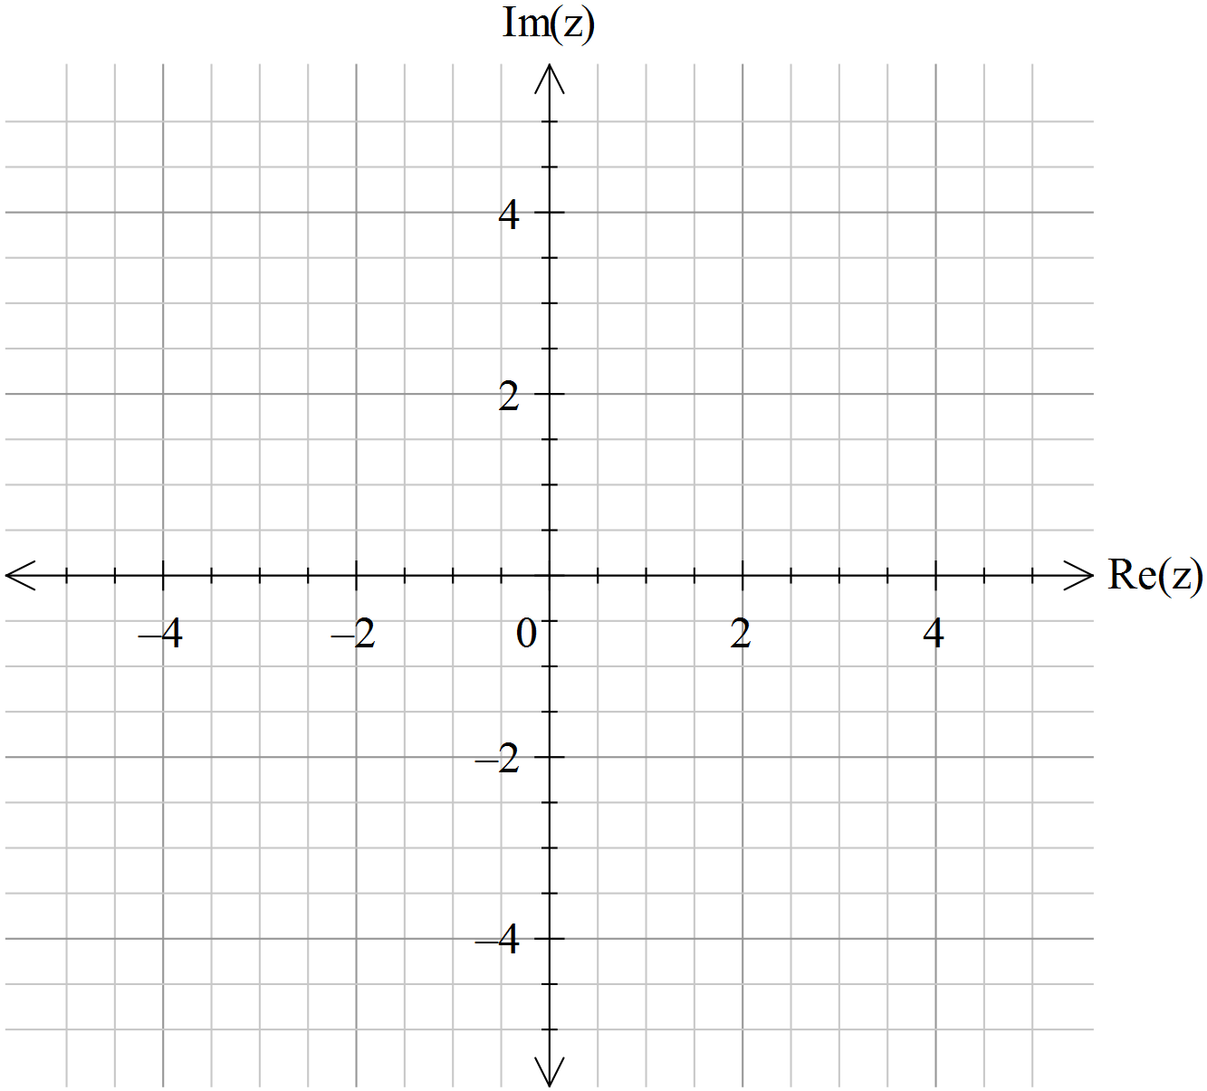

**b)** Determine to four decimal places the largest possible argument, , of the complex number that satisfies 

**8. (4,1 marks)**

**a)** Use de Moivre’s theorem to show that $\cos{4x}=\cos^{4}{x}+\sin^{4}{x}-6\cos^{2}{x}\sin^{2}{x}$

**b)** Use this result to show that $\cos{4x}=1-8\cos^{2}{x}\sin^{2}{x}$

**End of Test**